PROJECT DESIGN PHASE 2
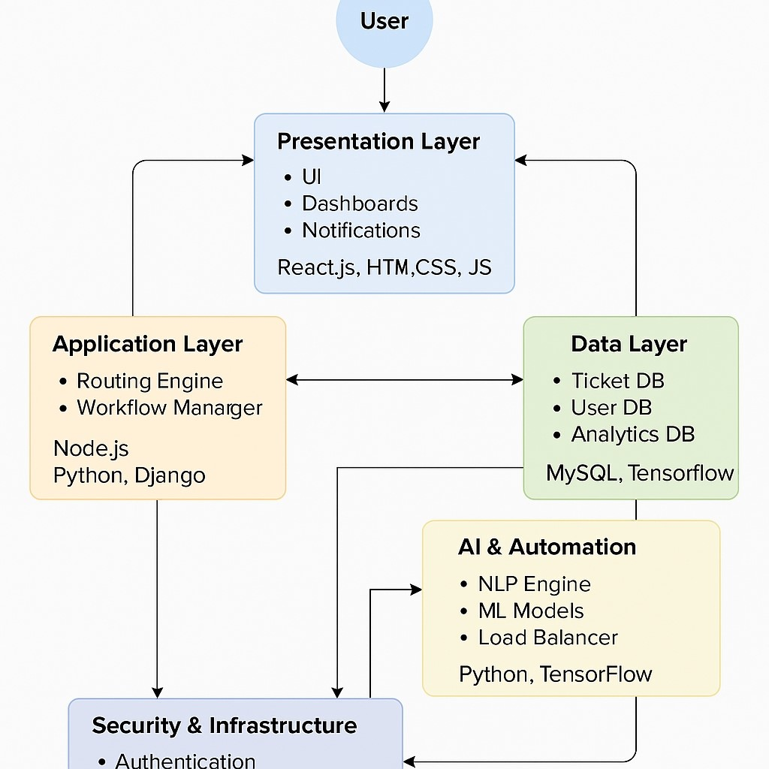
TECHNOLOGY STACK (ARCHITERTURE& STACK)

Date | 02 NOVEMBER 2025
Team ID | NM2025TMID03455
Project Name | Streamlining Ticket Assignment for Efficient Support Operations
Maximum Mark | 4 Marks
Technical Architecture:
The technical architecture for the Streamlining Ticket Assignment for Efficient Support Operations project is designed as a modular, scalable, and secure system to ensure efficient automation and data-driven decision-making. It follows a three-tier architecture consisting of the Presentation Layer, Application Layer, and Data Layer, supported by intelligent automation and analytics modules.
Components and Technologies:
- User Interface (UI)- Dashboards-  1. Presentation Layer Notification Center- Reporting & Analytics Views | HTML5, CSS3, JavaScript,  React.js / Angular, REST APIs  Node.js, Python (Flask /  Django), Express.js, Java  Spring Boot
Layer Components

Technologies / Tools
MySQL, PostgreSQL, MongoDB, Firebase
Python, TensorFlow, Scikitlearn, spaCy, NLTK OAuth 2.0 / JWT, SSL/TLS,
AWS / Azure, Docker, Kubernetes
Grafana, Kibana, Prometheus,
Power BI

- Ticket Routing Engine- Workflow
- Application Layer Manager- Notification Service-
Integration Module
  - Ticket Database- User Database-
- Data Layer Analytics Database- Logging & Audit
Database
- AI & Automation - NLP Engine- Machine Learning Model-
Layer Load Balancer
  - Authentication & Authorization- Data
- Security &
Encryption- Cloud Deployment- Backup
Infrastructure Layer
& Recovery
- Monitoring & - System Monitoring Tools- Performance
Reporting Layer Metrics Dashboard- Log Management

